
République Du Cameroun
Paix-Travail-Patrie
PK Fokam Institute of Excellence

Republic Of Cameroon
Peace-Work-Fatherland
PK Fokam Institute of Excellence

Project: Wedding Invitation and Gift Management System (WIGMS)

Third Progressive Report

V1.2

GROUP 1
NAME | MATRICULE | PERCENTAGE PARTICIPATION
TCHOUNGA NGATCHOU MARIE CLAIRE | 26S022 | 18.5%
MASSADO DJOKO AICHA CLAUDIA | 26S033 | 18.5%
NKOMPNANG GUILLAUME JUNIOR | 26S017 | 18.5%
AVOUTIA DONGMO BRAYANN | 26S028 | 18.5%
NZANUM RYAN DZEMBUIN | 26S007 | 13%
Chi Rawlings Ngang | 25S021 | 13%

SUPERVISOR: MR MBIETIEU AMOS
Academic Year: 2025/2026

Table of Contents

- Introduction ……………………………………………………………………….3

- Gantt Chart ………………………………………………………..3

- System Design …………………………………………………………………3

- Sequence diagram……………………………………………………………4

- Deployment diagram………………………………………………………….6

- Class diagram…………………………………………………………………6

- Work distribution………………………………………………………………7

- Module One…………………………………………………………………….8

- GitHub Repository……………………………………………………………12

- Module Two…………………………………………………………………..16

- Repository Link……………………………………………………………….17

- Graphic User Interface………………………………………………………18

- Tools And Technologies used……………………………………………..24

- Difficulties encountered and Proposed Solutions………………………...24

- Next steps of the project……………………………………………………..25

- Conclusion…………………………………………………………………….25

Introduction
The aim of this project is to design and implement a Wedding Invitation and Gift Management System using the C programming language. The system is developed using a modular approach, allowing each component to be built, tested, and improved independently.
This second report presents:
• The corrected version of Module 1: Person Management based on supervisor remarks
• The implementation of Module 2: Category Management
Special attention was given to improving the user interface, ensuring better usability before proceeding with advanced modules.

Gantt Chart

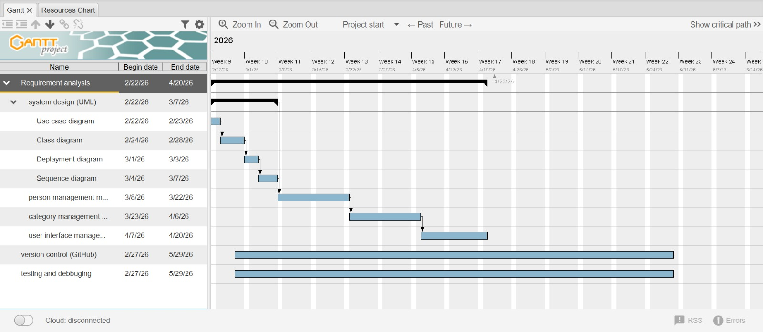

System Design
  - Use Case Diagram
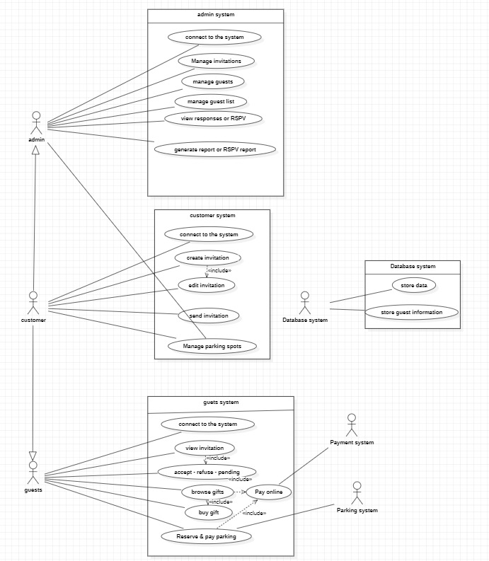

3.2 Sequence Diagram
3.2.1 Guest list management sequence
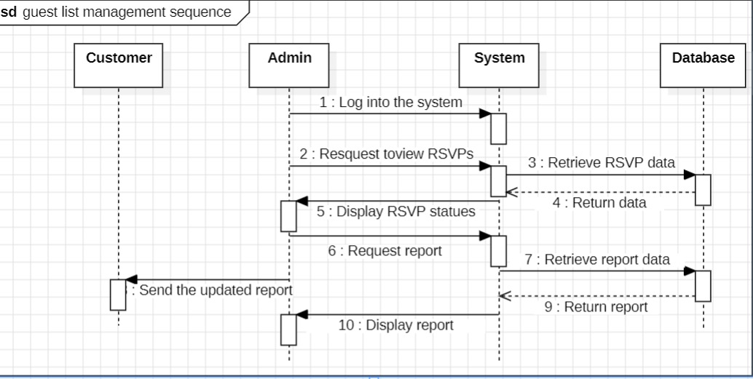

3.2.2 Invitation creation sequence
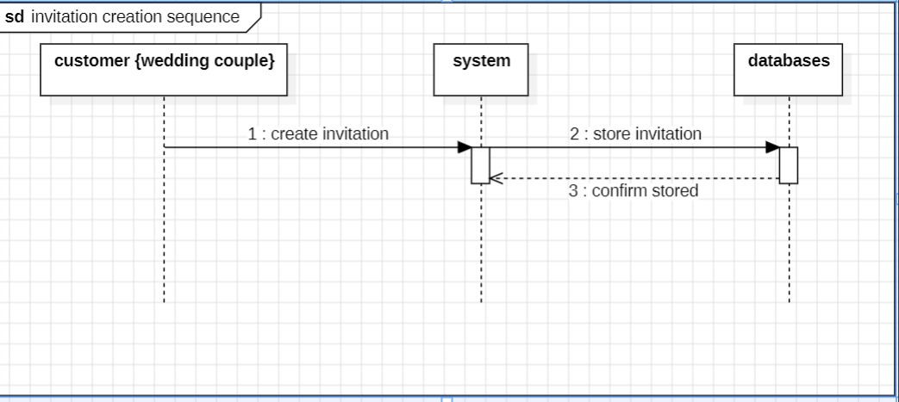

    - Respond sequence
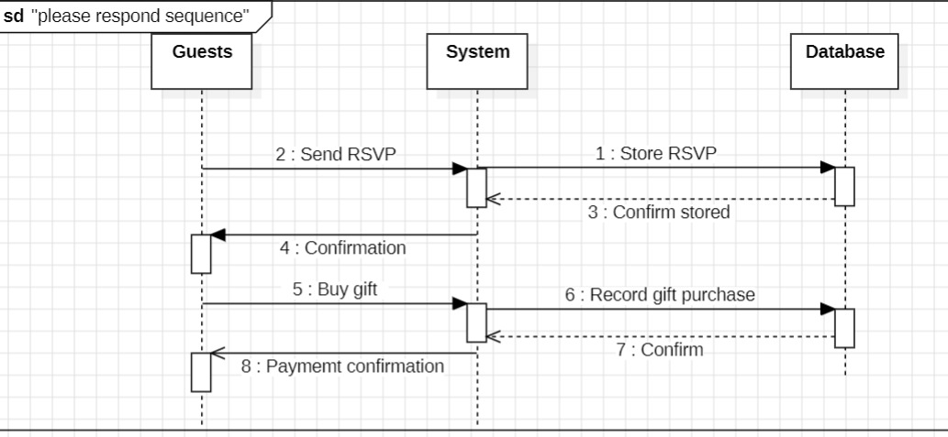

Deployment Diagram

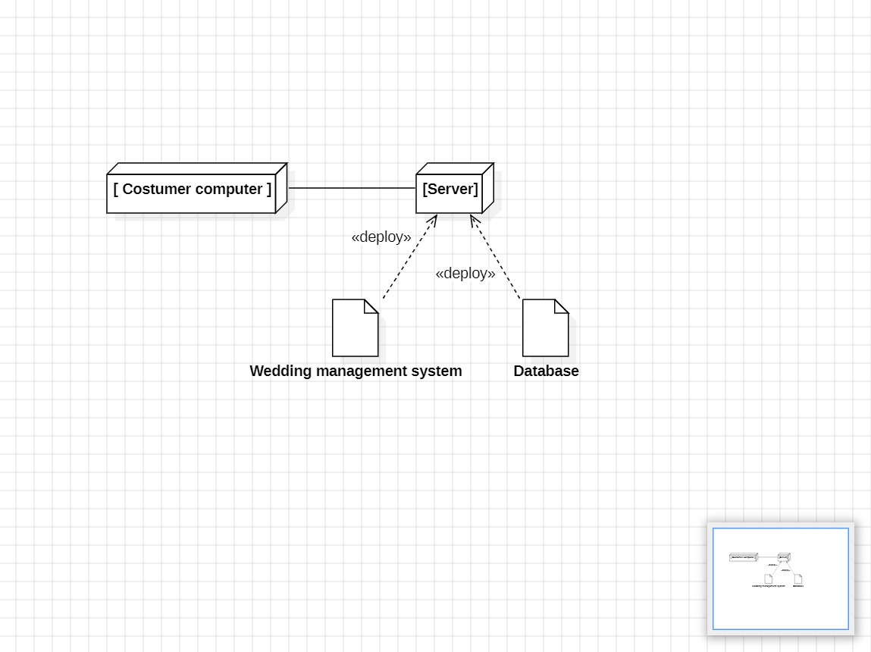

Class Diagram

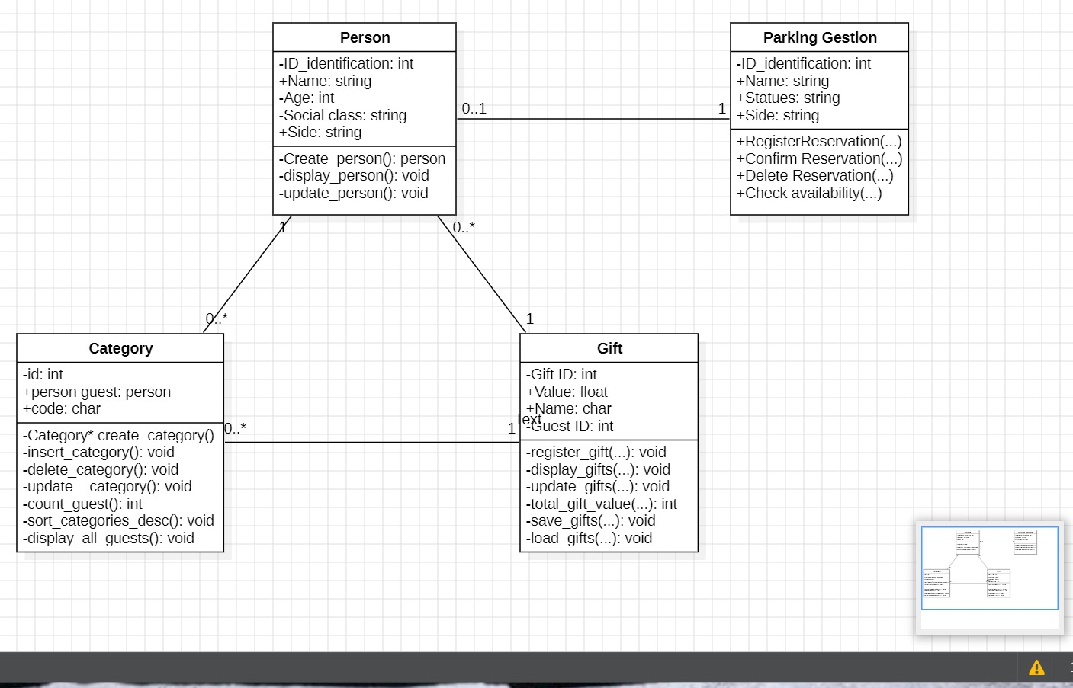

Work Distribution

Group Member | Role | Assigned Tasks
Tchounga Ngatchou Marie Claire | Project Manager and Coordinator | Overall project coordination and writing and formatting report
Avoutia Dongmo Brayann | Module 1 & 2 developer | Implementation of all libraries and debugging module 1 &2
Nkompnang Guillaume Junior | Module 1 & 2 designer | Graphical user interface design
Massado Djocko Aicha | System and Gantt chart designer | Case and sequence diagram design.
Nzanum Ryan Dzembuin | Data structure and algorithm | Implementation of delete category
Chi Rawlings Ngang | Documentation and GitHub manager | Managing GitHub repository

User Interface
To improve interaction with the system, a simple user interface was introduced using standard input/output functions in C. The interface allows users to navigate through the program using a menu-driven approach.
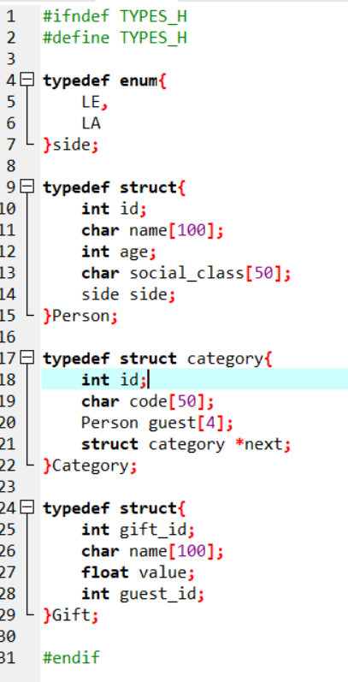

MODULE 1: PERSON MANAGEMENT

Objectives of the Module
- Define a Person structure to store guest information.
- Implement a function to create a new person.
- Implement a function to display a person's information.
- Implement a function to update a person's information.
- Apply structured programming concepts using C language.

- Person Structure
A Person represents an invited guest. The structure stores basic information such as ID, name, age,
social_class.
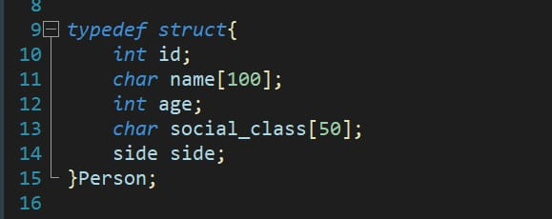

Implemented Functions

a.1 create_person ()
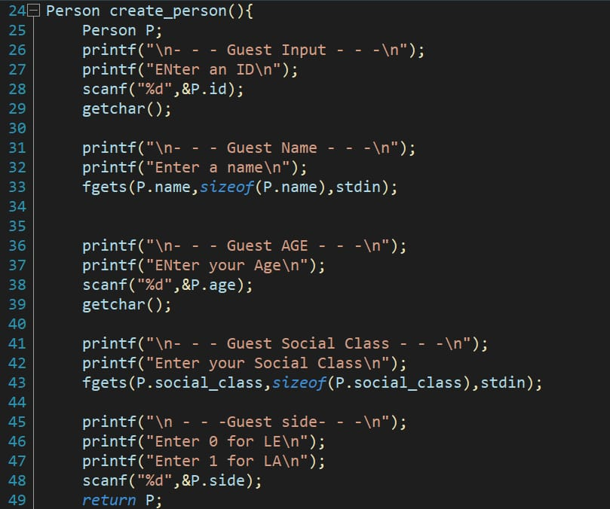

a.2 Create_Person() (Parking)

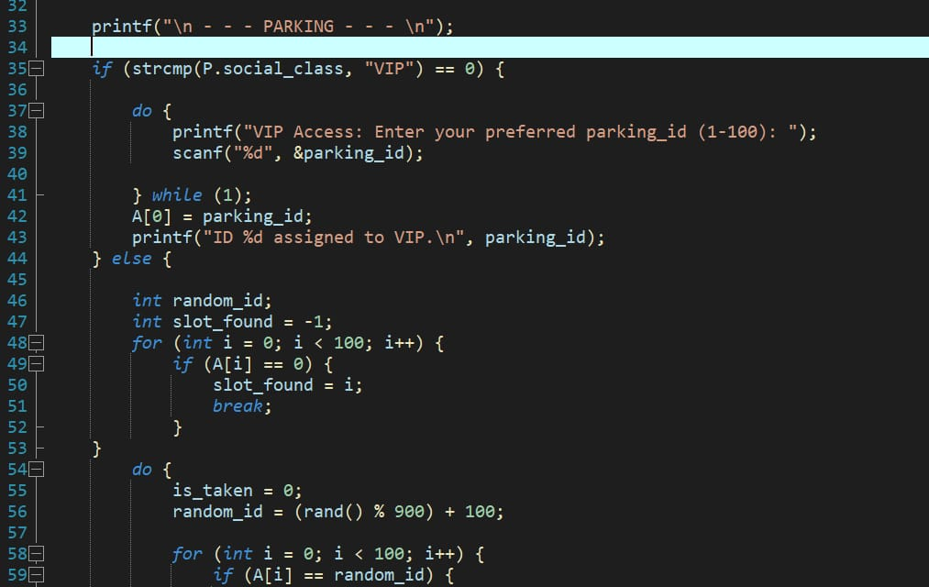
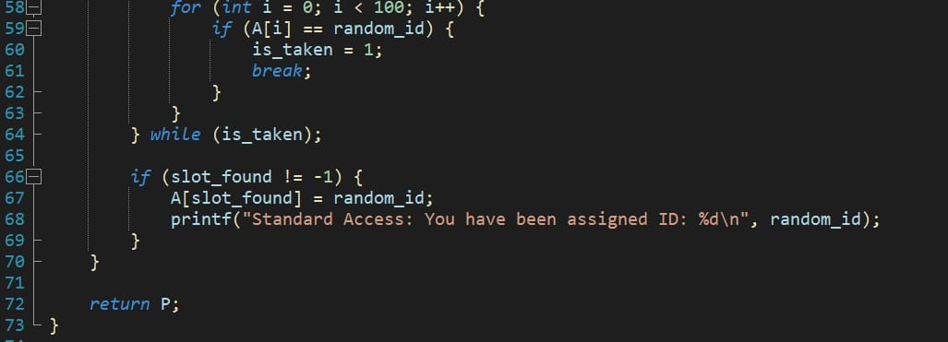

display_person ()

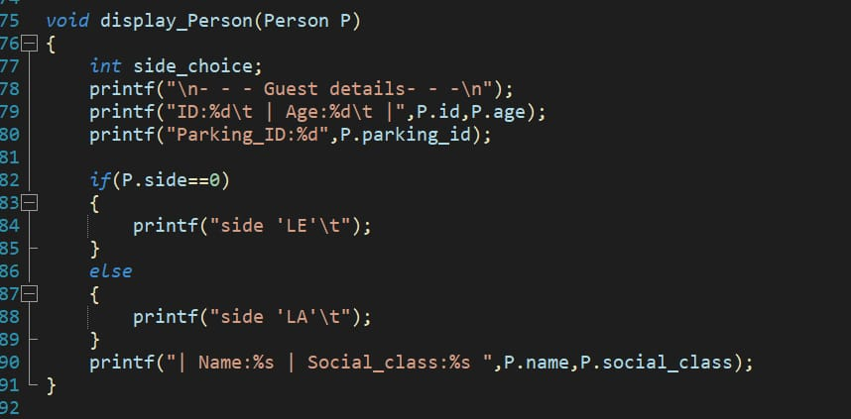

Graphic User Interface

Person Module for Graphic User Interface
: For the person module graphic user interface, we are handling the regidtration of the different guests that will participate to the event, the modification of their entered paramaters and the suppression of those whose turned down their invitation. In this program, we can do a lot of tasks like;
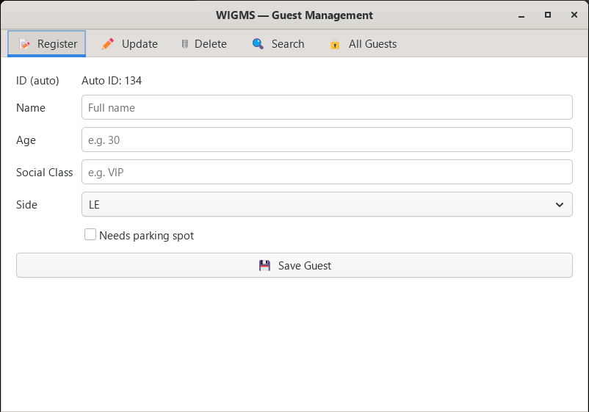
- The Registration: here, we are registering the different guests which would like to attend to the ceremony. The user will have to enter his/her entire name, age and social class. We also made ourselves sure to let the ID of each person be automatically generated and to leave a check box to say if he need a parking spot or not. It is as we can see here below:

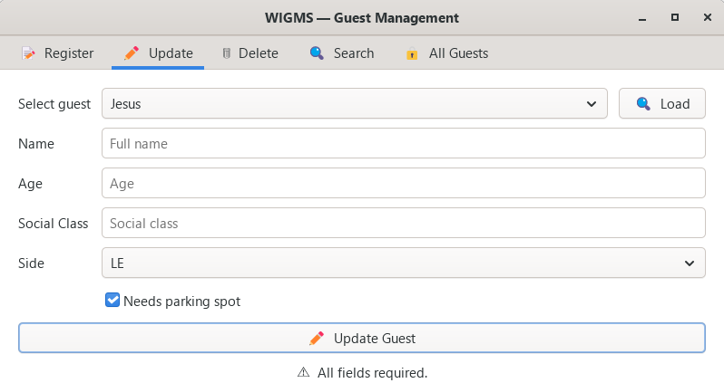
- Update: here we have the ability to modify the information on each guest just by entering the name of the of the person in the research space and just modifying the information which are already inside the person description. Like here:
- Delete: : It’s an option where it’s possible for an user to delete an existant guest and the informations about him in the case that you have created a person which where not supposed to exist. It’s like on this picture, where you just have the charge of write the name of the person and select delete.
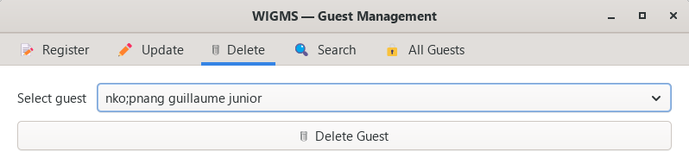

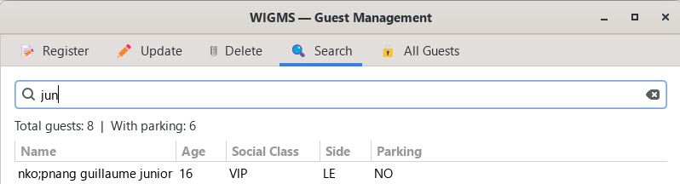
- Search: Here is an option where you can look for somebody in the list if guest by looking for his name or his social class in the search bar. It can be use to group the people by social class or by name.

- All guests: this class give to a user the access to all the guests which were registered in the program, the number of Guests which were stocked in the program, the ID of all the guests that where created in the application and the total number of parking spot assigned to guests. Since the ID and the information about the different Guests are confidential, we thought that it will be wise to protect them with a password which is “pokemon” in order to assure the protection of their data. The presentation of this page is like this:

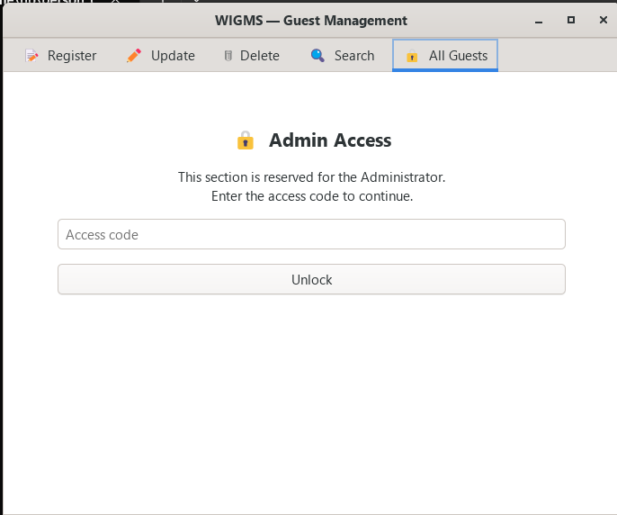

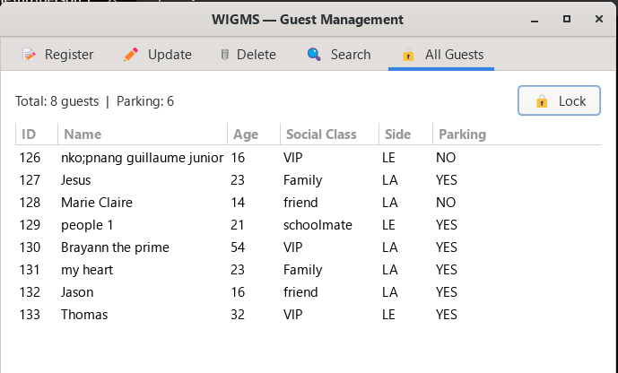

Setting Up a GitHub Repository
To create a GitHub repository using the web interface, follow these steps:

Step 1: Creating the GitHub accounts
To sign up for an account, navigate to https://github.com/ and follow the prompts. To keep your GitHub account secure you should use a strong and unique password.

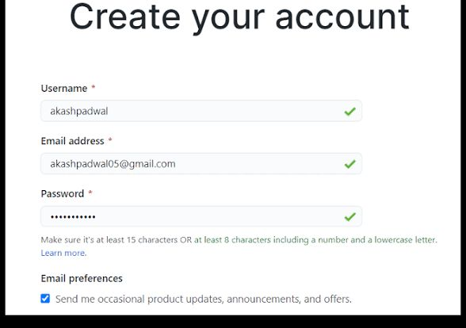

Step 2: Creating the Repository
Start a new repository in the upper-right corner of any page, select the plus (+) icon, then click New repository

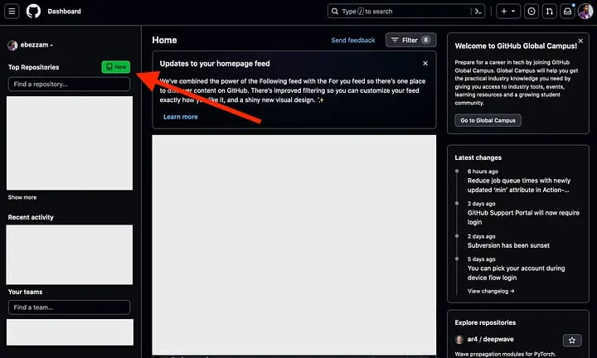

Step 3: Specify an owner
If you belong to any organizations, use the "Owner" dropdown menu to select the account (your personal account or an organization) that will own the repository. Enter a name — type a short, memorable name for your repository in the "Repository name" box.

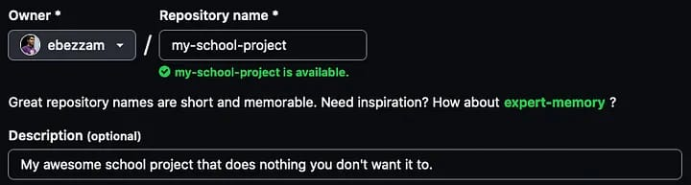

Step 4: Choose repository visibility
Decide whether the repository will be Public (anyone can see it) or Private (only you and collaborators you choose can access it).

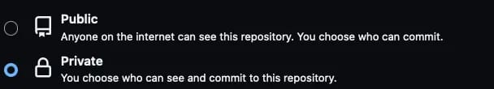

Step 5: Initialize the repository
Select Add a README file to create a document that describes your project. You can also optionally add a .gitignore file (to exclude specific file types from version control) and a license.

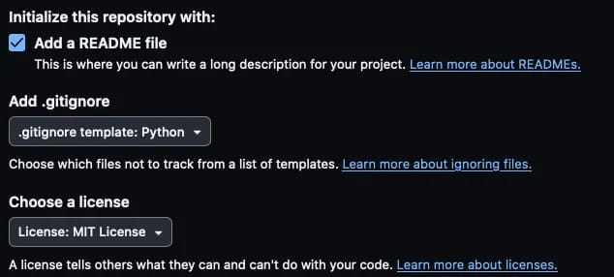

Step 6: Create the repository
Click the green Create repository button at the bottom of the page.

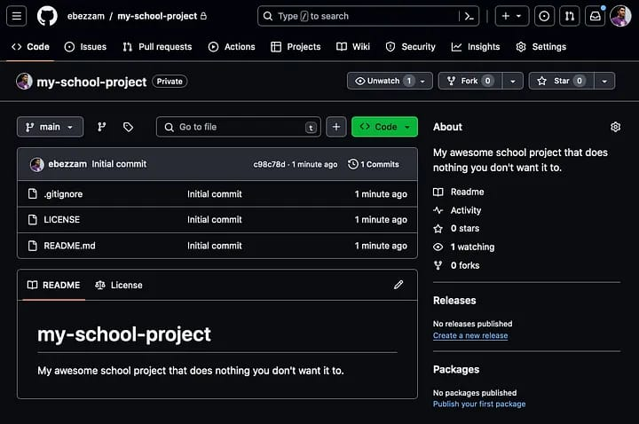

Step 7: Start using your repository
GitHub repository is now created and ready for you to start adding files and managing your project with version control. You can then clone the repository to your local machine using the provided URL to work with it locally.
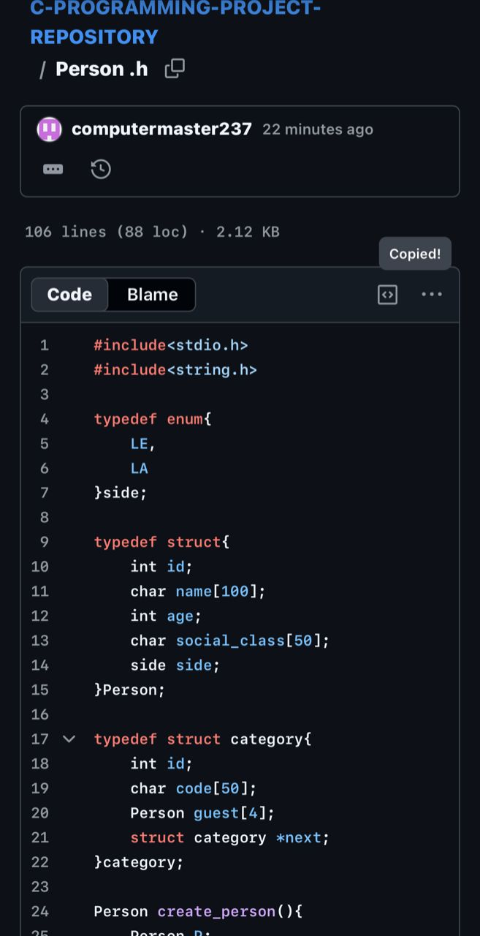

MODULE 2: CATEGORY MANAGEMENT

Objectives

• Organize guests into categories
• Use linked lists for dynamic storage
• Improve system structure

Category Structure

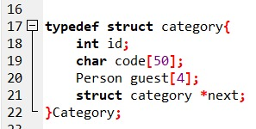

Implemented Functions
3.1 Create_Category

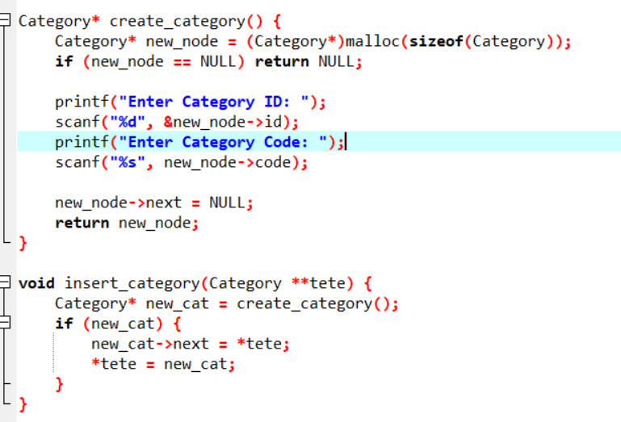
3.2 Update_category
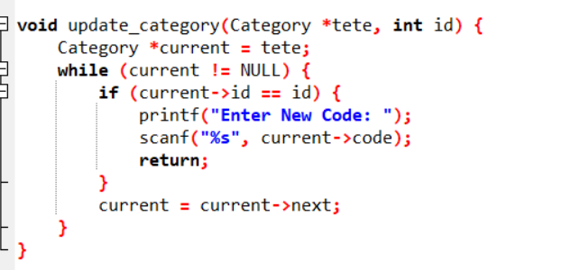

3.3 Delete_category

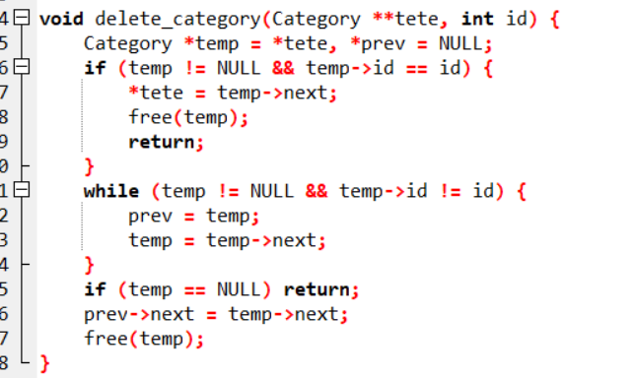

Linked List Explanation
Categories are stored using a linked list:
• Each node represents a category
• Nodes are connected using pointers
• Allows dynamic insertion and deletion

Repository

The GitHub repository was created and validated by all group members. The project can be accessed using the following link: https://github.com/C-programming-project-1/C-PROGRAMMING-PROJECT-REPOSITORY

Graphic User Interface (GUI’s)

Home page
Here in this program, we can see the home page is handling two main part:
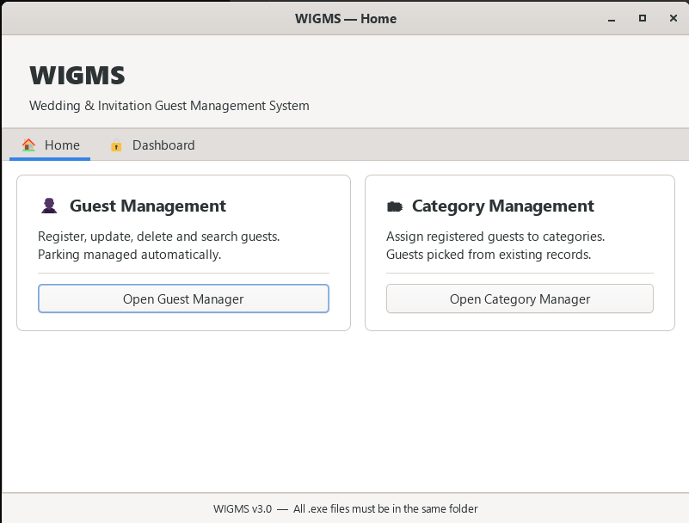
- The Home: that’s where each user come to connect itself in order to have access to the differents functionalities of the application. Here, since we have just handled two module (and occasionally the third one); we could have access to the person/Guest management system and to the category management system.

- The Dashboard: Here, we are handling a general presentation of all the data which are manage by the application through a sort of recapitulative page in order to let the admin of the application have a general view of the data mange by the app. Since the dashboard is a page where the data of all the people are presented, we think that this part should be confidential and be exclusively accessible to the Admin of the app. That’s why to access to this page, the user should know the access key of the dashboard, which is “pokemon 1”. After entering the access key, you could have the access to all the data of the programm as you can see below
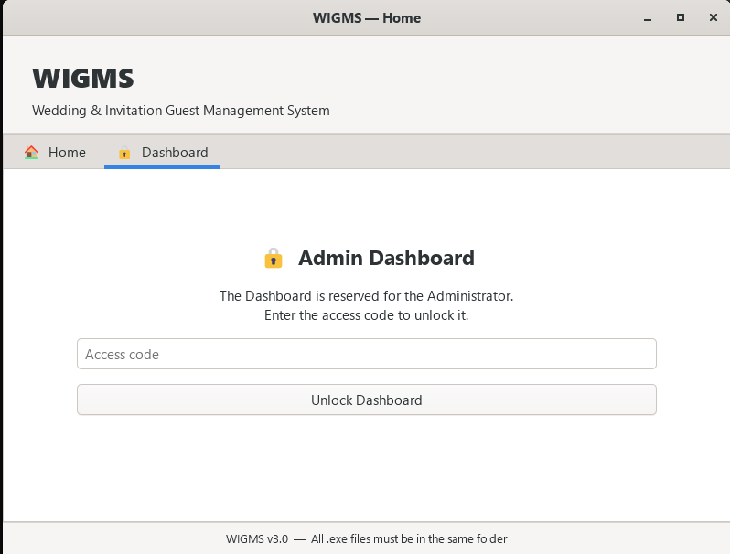

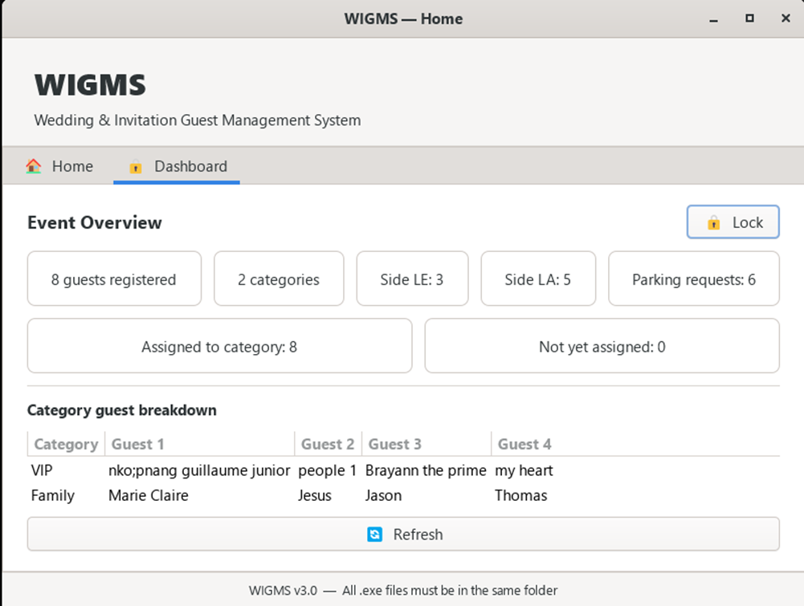

Category Module for Graphical User Interface
In the category module, we are handling the different kind of people which could come to register themselves: the friend, the family, the VIP guests, the partners, etc. Here, there are a lot of tasks which can be done, all subdivided into Classes. They are:

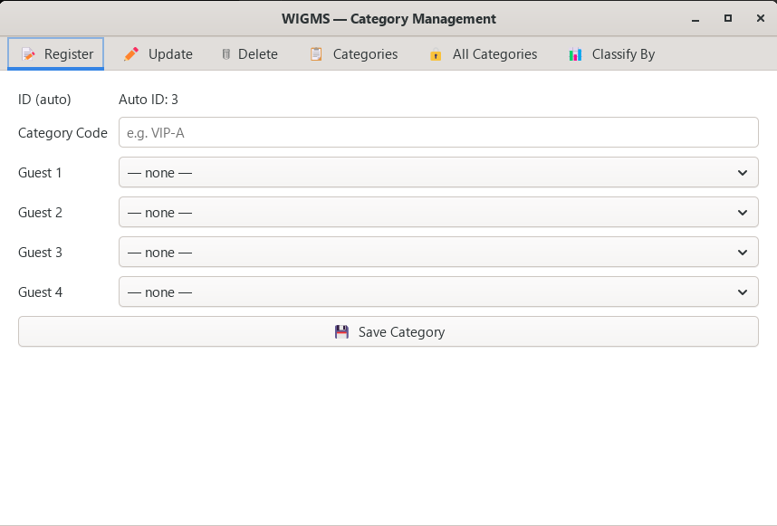
- Register: here, we are registering the different category of people which will be used for the organization of the ceremony. Here, we linked the person and the category module in order to enable the different guest which are already register to be automatically assign to an existent category. We also made ourselves sure to let the ID of each category to be automatically generated in order to leave redundancies and promote privacy in the program
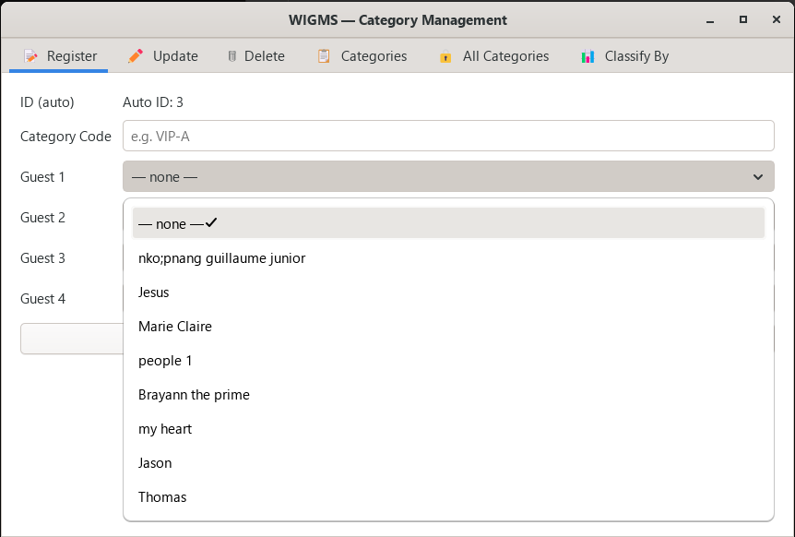

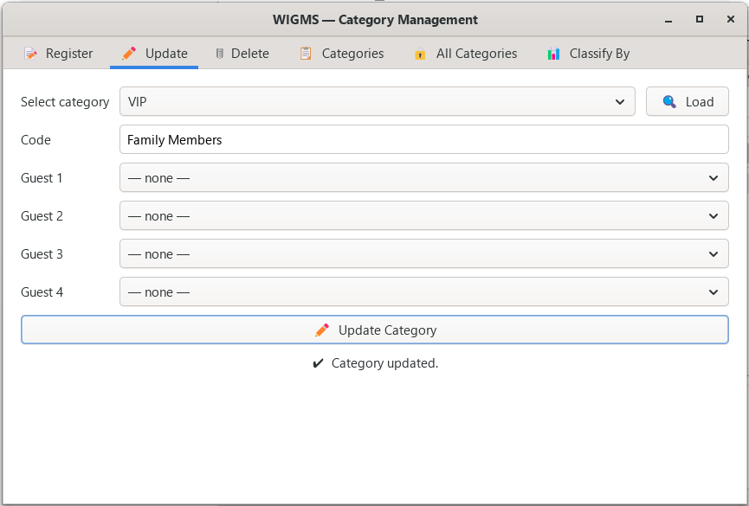
- Update: here we have the ability to modify the information on each category just by entering the name of the of the category in the research space and just modifying the information which are already inside the category description. Like here, we change the already existant VIP category into family members

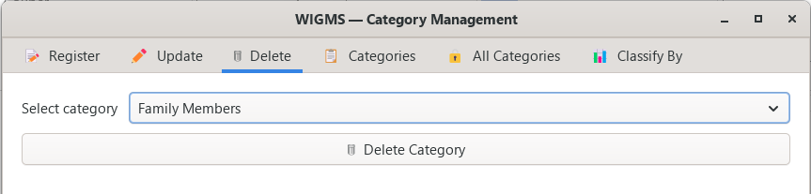
- Delete: It’s an option where it’s possible for an user to delete an existant category and the contant of these in the case that you have created an category which where not supposed to exist. It’s like on this picture, where you just have the charge of write the name of the category and select delete.

- All categories: this class give to a user the access to all the different categories which were generated by the program, the total number of categories, and the number of Guests which were assigned to a category, the ID of all the categories that where created in the application. Since the ID and the information about the different Guests and categories are confidential, we thought that it will be wise to protect them with a password which is “pokemon” in order to assure the protection of their data. The presentation of this page is like this:

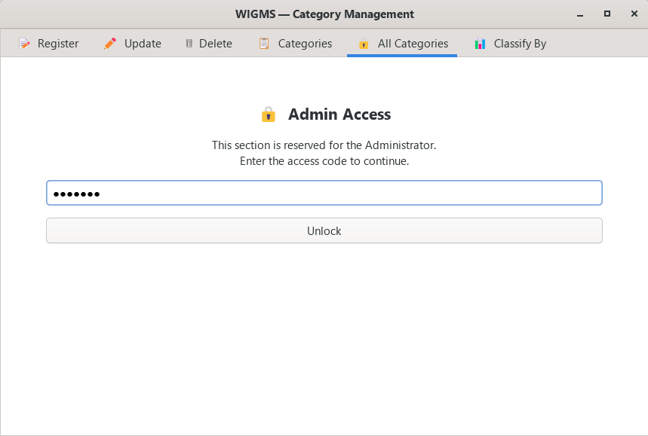

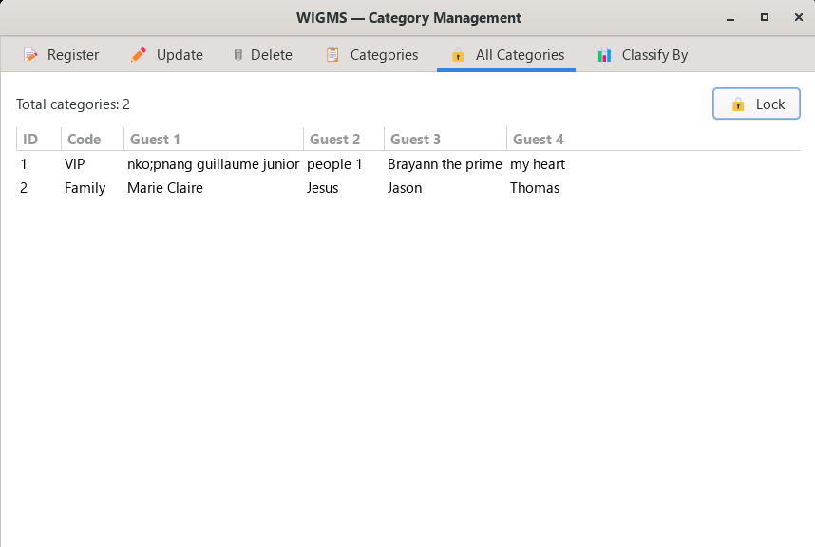

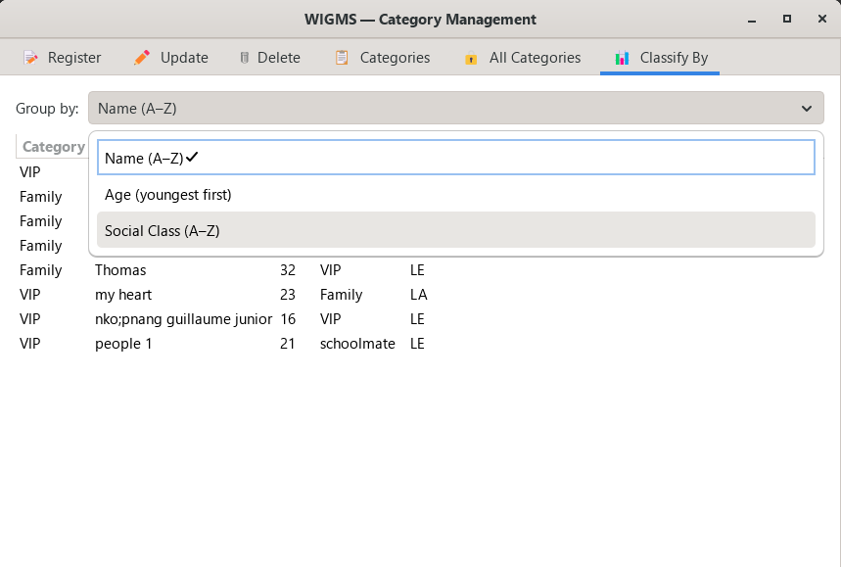
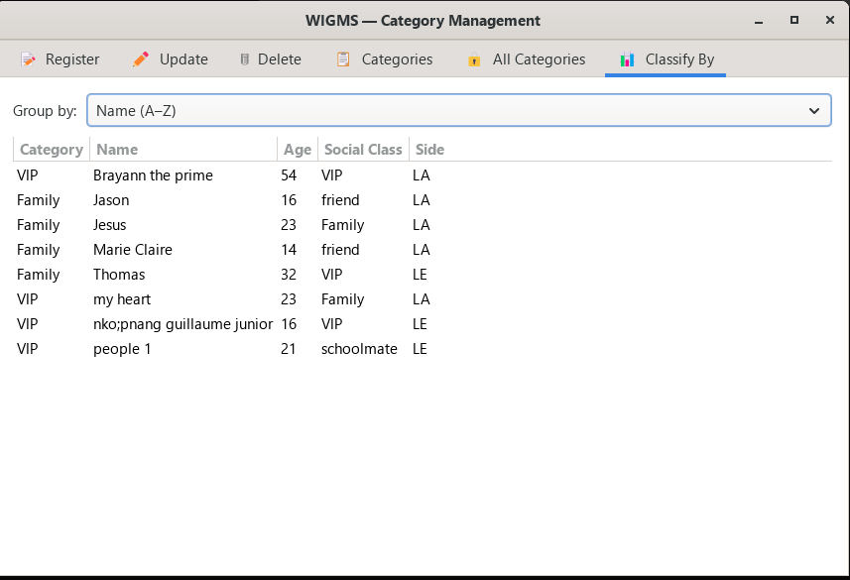
- Classify by: here, we are a bit treating the functionalities of the third module. In this class, we are classify the entered by Guest according to some criteria like the name, the age or the social class in order to prioritize some category during the ceremony towards other one. It’s as we can below:

Tools and Technologies Used

- C Programming Language for software development.

- GitHub platform for version control and team collaboration.


- Standard C libraries such as stdio.h and string.h

Difficulties Encountered and Proposed Solutions
During the development of the Wedding Invitation and Gift Management System, the group encountered several general challenges that affected both Module 1 and Module 2. These challenges were related to programming concepts, system design, and teamwork. However, appropriate solutions were applied to ensure the successful progress of the project.
8.1 Difficulty in Managing Dynamic Data Structures
The implementation of linked lists in Module 2 introduced another challenge. Unlike static data structures such as arrays, linked lists require proper handling of memory allocation and pointer connections between nodes. Errors such as incorrect linking of nodes, loss of data, and program crashes occurred during testing.
Proposed Solution:
The group used diagrams to visualize how linked lists work and how nodes are connected. Step-by-step tracing of the code was performed to identify errors. Additional practice on linked lists helped improve understanding and correct implementation.
8.2 Difficulty in Handling User Input
Managing user input using functions like scanf () was problematic, especially when handling both strings and integers. Issues such as skipped inputs and incorrect data reading were encountered.
Proposed Solution:
The group reviewed proper input handling techniques and improved the structure of input statements. Additional validation checks were introduced to ensure correct data entry. Extensive testing was conducted to eliminate input errors.
8.3 Difficulty in Time Management and Task Coordination
Coordinating tasks among group members and meeting deadlines was sometimes difficult due to different schedules and workloads.
Proposed Solution:
Tasks were clearly assigned to each member, and deadlines were set for each phase of the project. Regular communication and progress tracking ensured that the work was completed on time.

Next Steps of the Project
The next phase will focus on:
• Implementing Priority Management (sorting algorithms)
• Developing Gift Management module
• Designing the User Interface
• Testing and debugging of system.

Conclusion
This third report highlights both the correction of Module 1 and the successful implementation of Module 2.
The project has significantly improved the group’s understanding of:
• Structures
• Pointers
• Linked lists
• Modular programming
Additionally, the introduction of a user-friendly interface has made the system more interactive and efficient.
This module lays a strong foundation for the continuation of the project.

PKFokam Institute of Excellence — C Programming Course — Academic Year 2025/2026

